COMMUNICATION LABORATORY
Experiment 6: Design of IIR Butterworth LPF, BPF and FIR filters using Hamming window method

NAME: N DEEKSHITHA
ROLL NO: 24EC10105
GROUP 16 (Thursday Batch)
OBJECTIVE:
- To design IIR Butterworth Low Pass Filter (LPF) and Band Pass Filter (BPF) in MATLAB.
- To design FIR filters using the Hamming window method in MATLAB.
- To analyze magnitude and phase responses of the designed filters.
- To apply the filters on the audio signal and observe the spectrum before and after filtering.
PROCEDURE:
Design of LPF and BPF in MATLAB
- First, calculate the normalized cutoff frequency using the cutoff frequency and the sampling frequency. The normalized frequency is given by
Wn=Fc/(Fs/2)
where Fc is the cutoff frequency and Fs is the sampling frequency.
- Using this normalized frequency, design a 3rd order Butterworth Low Pass IIR filter, Butterworth Band Pass IIR filter in MATLAB to obtain the filter coefficients.
- Next, design the FIR filter using the truncation( Hamming window method).
w(n) = 0.54 - 0.46 cos(2πn/(N-1))
The maximum FIR filter order is limited to 20, and the filter order should be optimized so that the ripple in the passband does not exceed the limits specified in the filter specifications.
- Plot the magnitude response (Magnitude in dB vs Frequency in kHz) and the phase response (Phase in radians vs Frequency in kHz) of the designed filters to analyze their frequency characteristics.
- Load the audio signal audio.mp3 and import it into MATLAB using the audioread command. The audio signal is then resampled to the target sampling frequency(i.e.LPF =20kHz, BPF=40kHz).
- Apply the designed IIR and FIR filters to the audio signal.
- Plot the magnitude and phase responses of the signal before filtering and after filtering to observe the effect of the filter on the signal spectrum.
- Store the filtered audio signal for further analysis and comparison.
- Finally, verify and compare the unfiltered and filtered signals using the online spectrum analyzer tool available at: https://academo.org/demos/spectrum-analyzer/
SPECIFICATIONS:
LPF:
Cutoff frequency=4.5kHz
Sampling frequency=20kHz
IIR filter order=3
FIR filter order=20
Passband ripple factor=0.1 Stopband ripple factor=0.5
BPF:
Higher cutoff frequency=12kHz
Lower cutoff frequency=8kHz
Sampling frequency=40kHz
IIR filter order=3
FIR filter order=20
Passband ripple factor=0.1
Stopband ripple factor=0.5
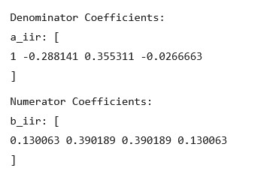
bfir: [
0.00254021 0.000565786 -0.00633611 -0.00555237 0.0170336 0.0242487 -0.0318285 -0.0764238 0.0447504
0.306556 0.448892 0.306556 0.0447504 -0.0764238 -0.0318285 0.0242487 0.0170336 -0.00555237 -0.00633611 0.000565786 0.00254021
]

RESULTS FROM MATLAB:

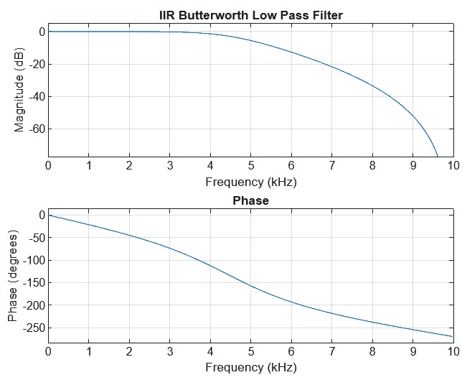

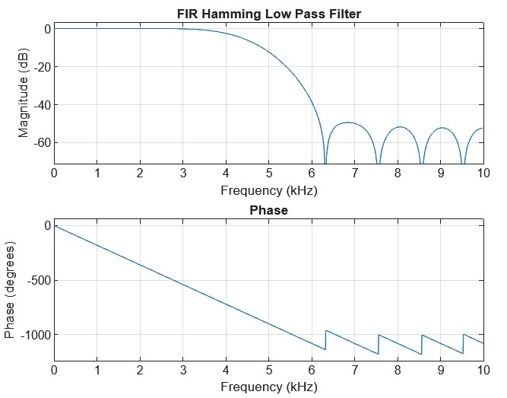
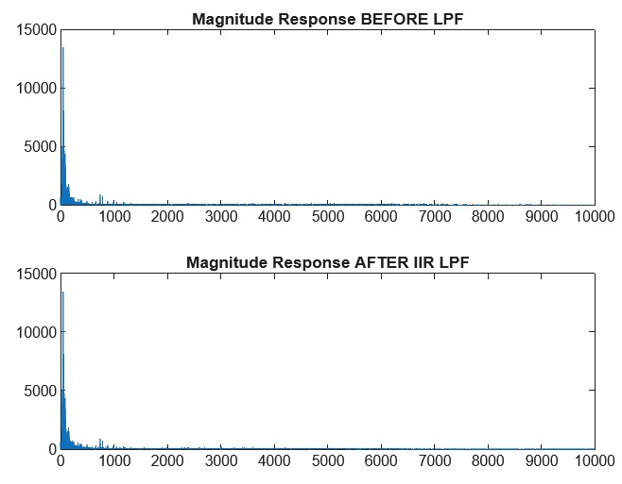
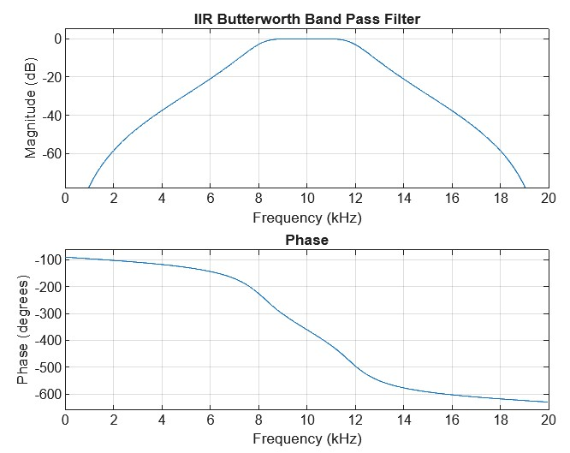
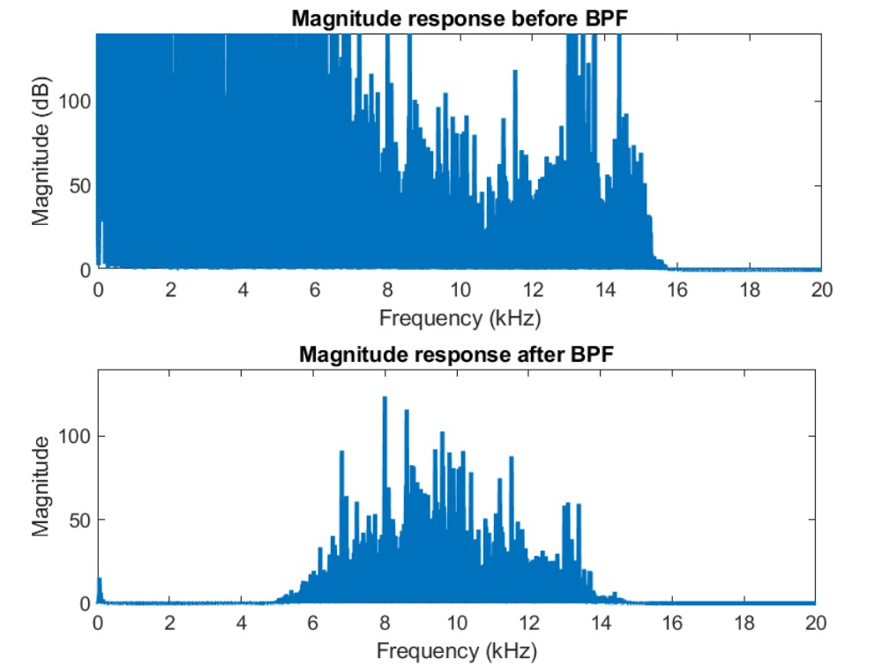

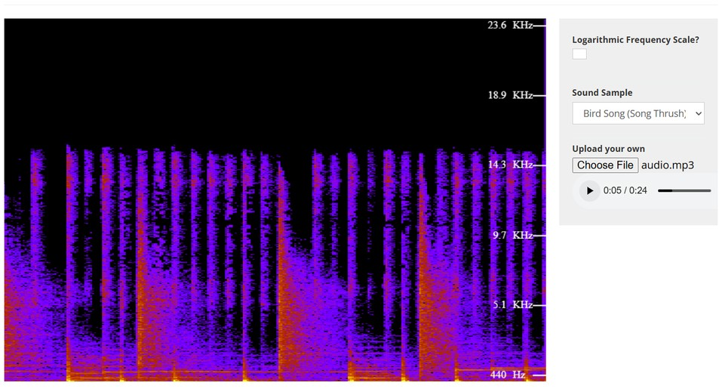

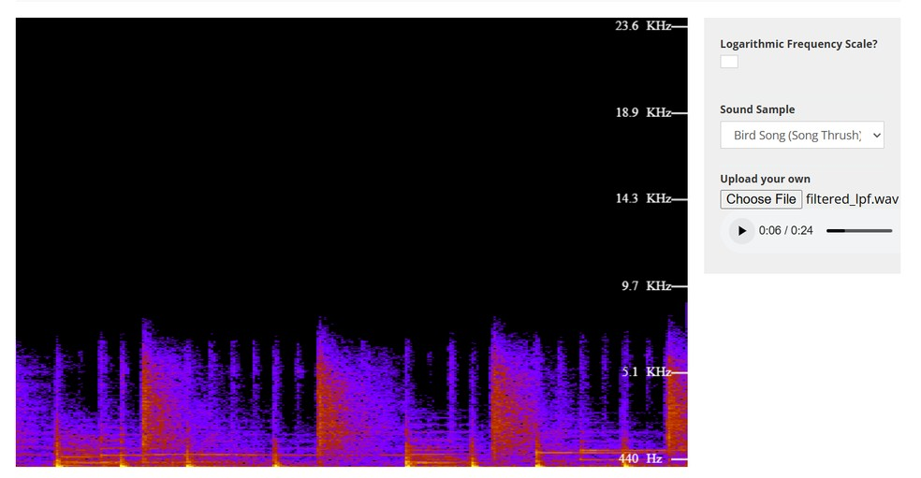
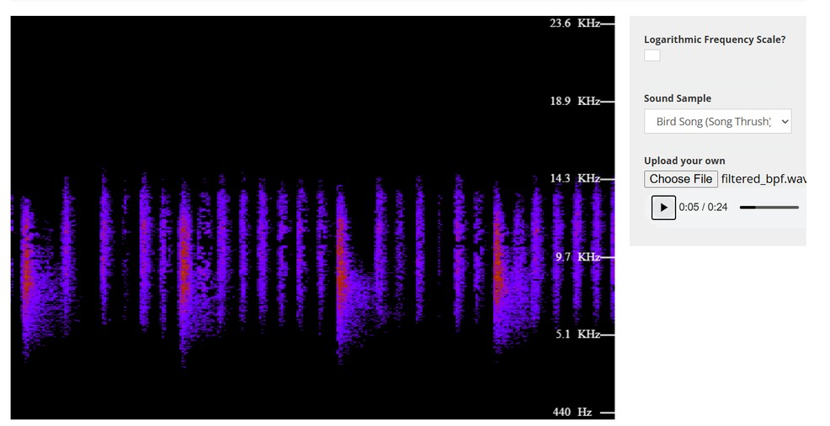
RESULTS FROM SIMULINK:
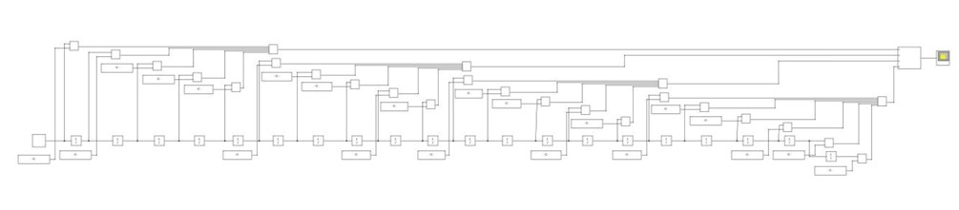
FIG: IIR BUTTERWORTH LPF DESIGN IN SIMULINK
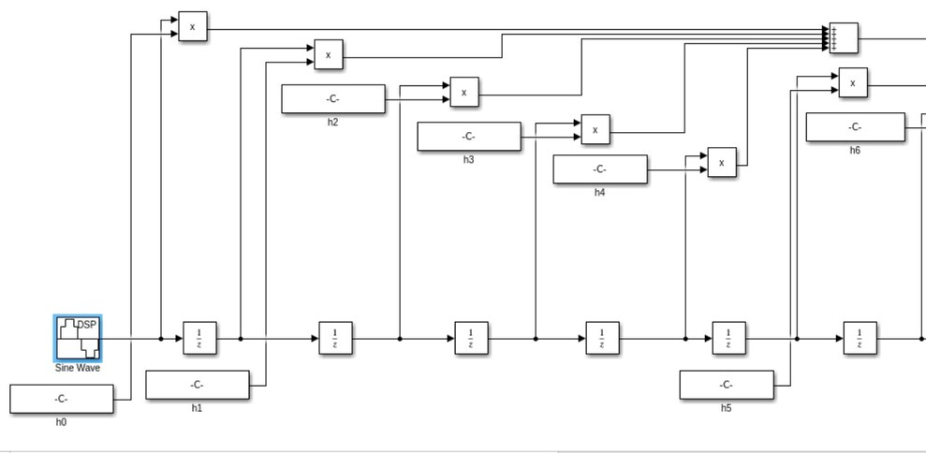
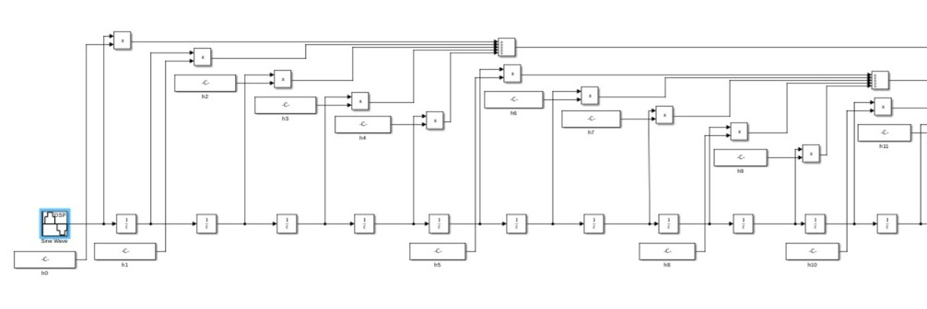
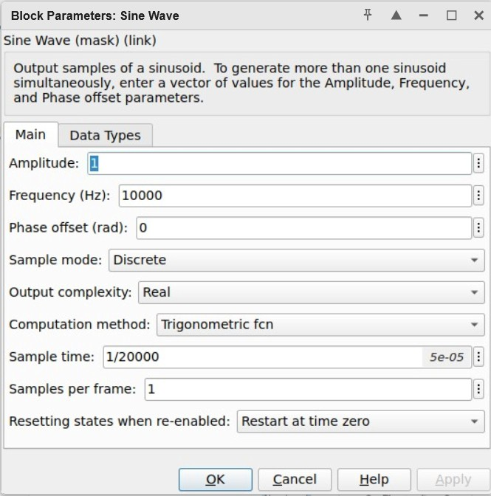
FIG: THE SINE INPUT AND THE OUTPUT IS AS FOLLOWS
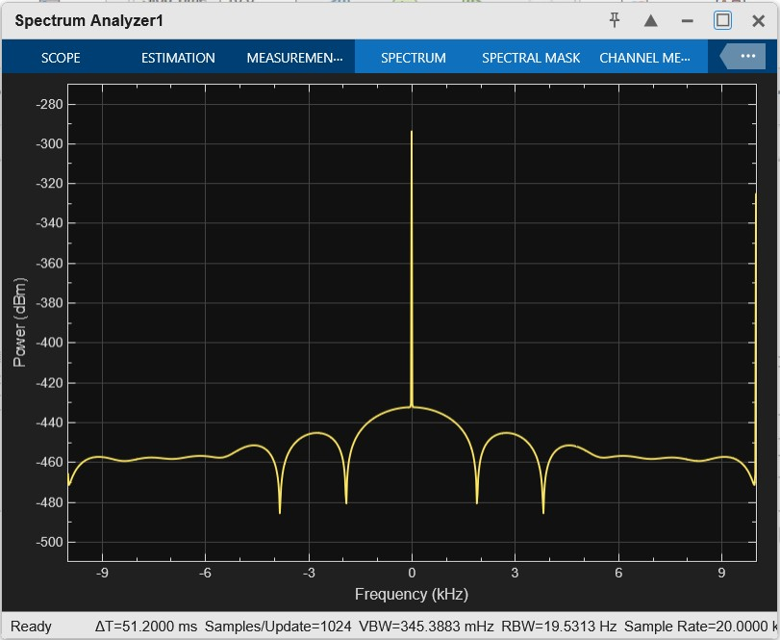
FIG: OUTPUT OF IIR LPF FILTER FOR THE ABOVE INPUT
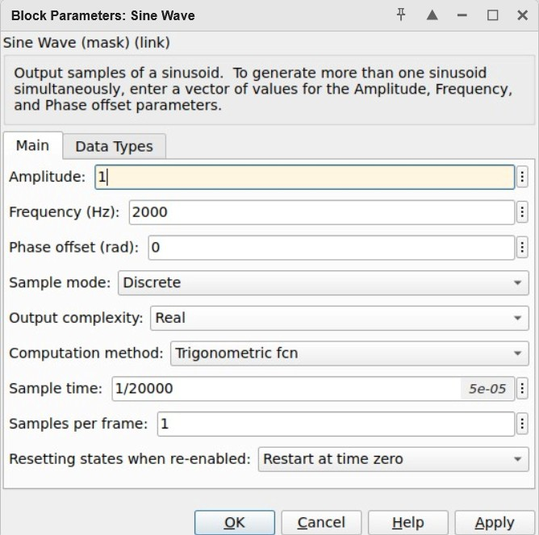
FIG: INPUT IN THE SINE WAVE AND THE OUTPUT IS AS FOLLOWS
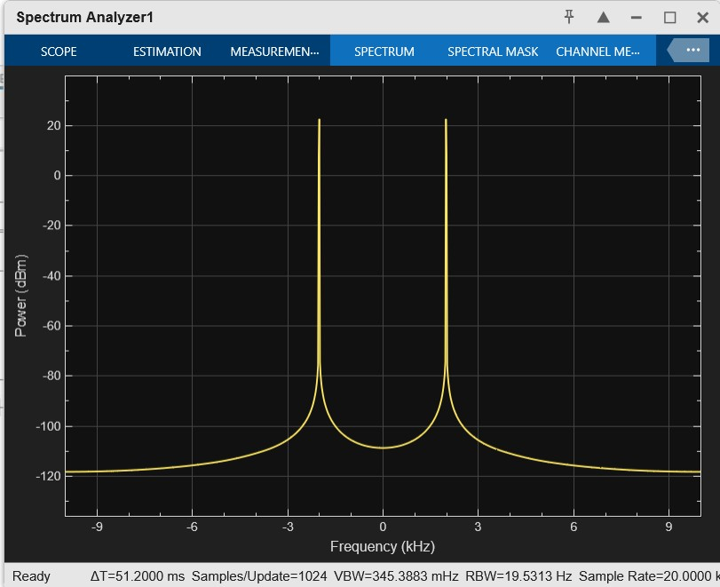
FIG: OUTPUT OF IIR LPF FILTER FOR THE ABOVE INPUT
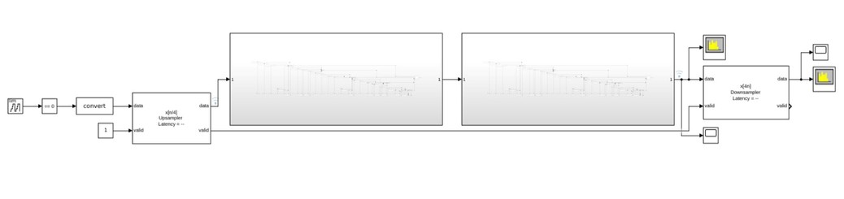
FIG: SIMULINK DESIGN FOR RAISED COSINE FILTER
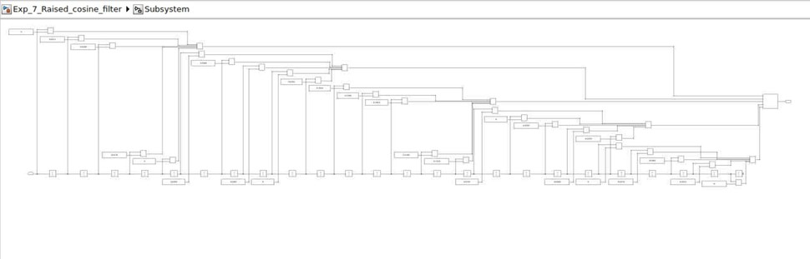
FIG: INSIDE THE IIR BUTTERWORTH LPF FILTER
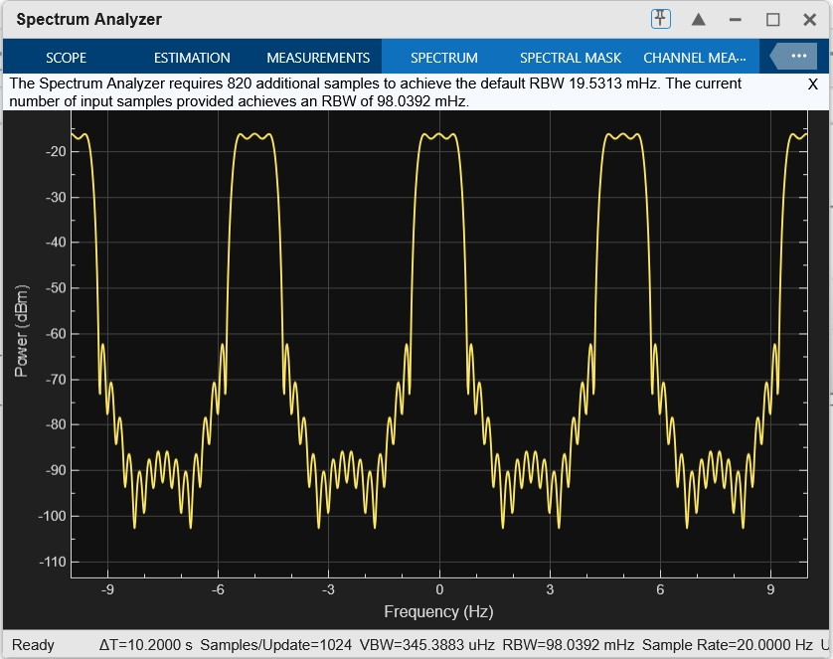
FIG: SPECTRUM ANALYSER AFTER TWO IIRS
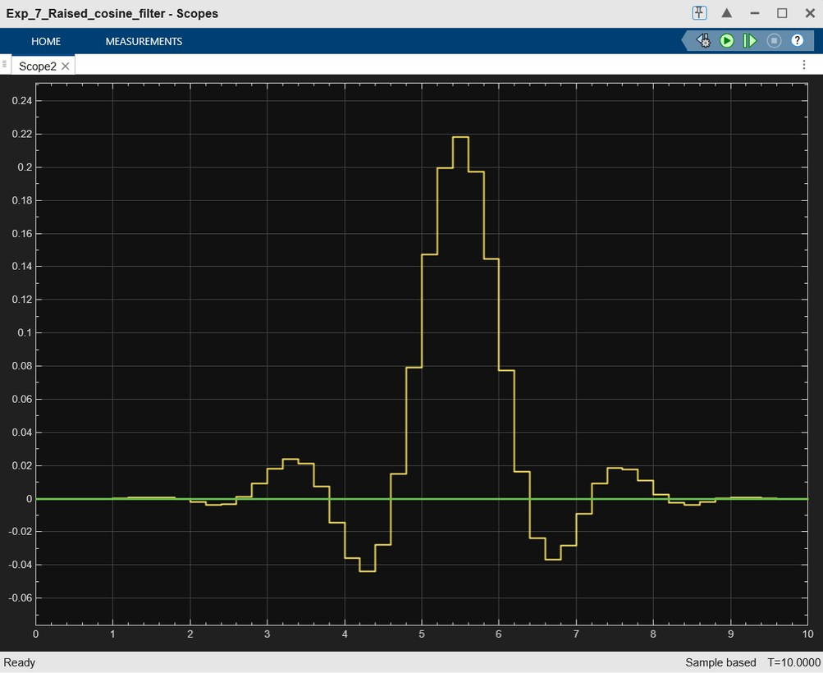
FIG: SCOPE AFTER TWO IIRS
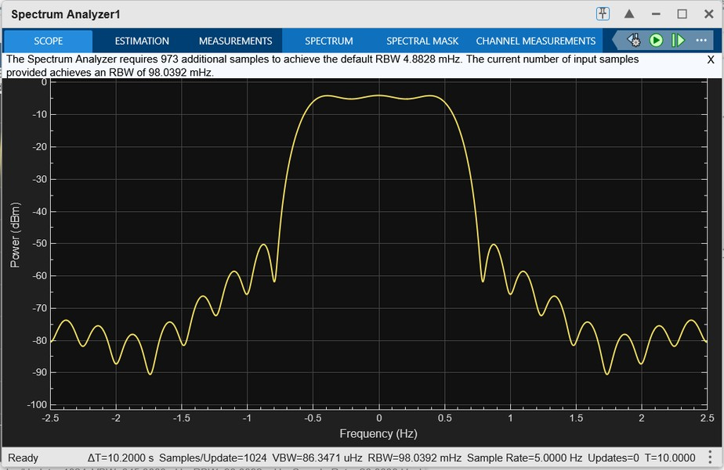
FIG: SPECTRUM ANALYSER AT THE OUTPUT
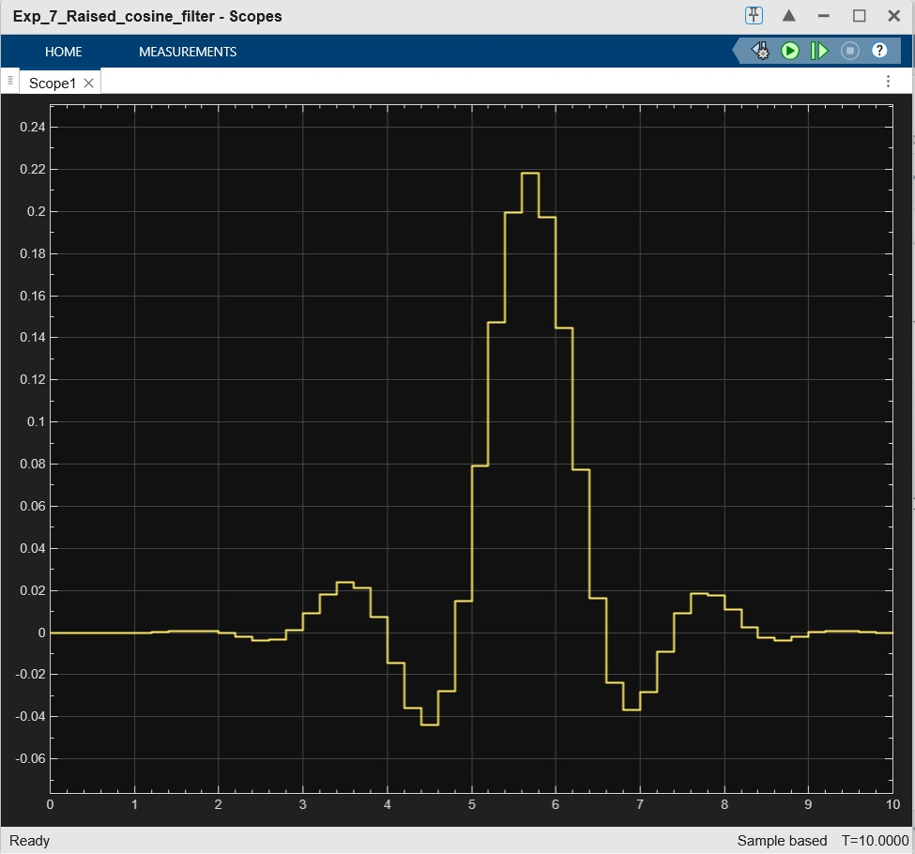
FIG: SCOPE AT THE OUTPUT

DISCUSSION
In this experiment, both IIR Butterworth and FIR filters using the Hamming window method were designed and analyzed for Low Pass Filter (LPF) and Band Pass Filter (BPF) specifications. The performance of these filters was evaluated through their magnitude and phase responses, and their effect on an audio signal was studied in both time and frequency domains.
- IIR Butterworth Filter Analysis
The Butterworth filter was selected due to its maximally flat response in the passband, which ensures minimal amplitude distortion.
For the LPF, the magnitude response showed a smooth roll-off after the cutoff frequency of 4.5 kHz, confirming that higher frequency components were effectively attenuated.
For the BPF, only frequencies within the range of 8 kHz to 12 kHz were allowed to pass, while frequencies outside this band were suppressed.
The phase response of the IIR filters was observed to be non-linear, which is a typical characteristic of Butterworth filters. This non-linearity can introduce phase distortion in the filtered signal.
- FIR Filter using Hamming Window
The FIR filter was designed using the Hamming window, which provides a good balance between main lobe width and side lobe attenuation, thereby reducing ripple effects.
The magnitude response of the FIR LPF also showed attenuation beyond the cutoff frequency, similar to the IIR filter, but with a slightly wider transition band.
The FIR BPF successfully isolated the desired frequency band between 8 kHz and 12 kHz.
A key observation is that the phase response of FIR filters was linear, which ensures that the signal waveform is preserved without distortion.
- Audio Signal Analysis (Before and After Filtering)
- Before filtering, the audio signal spectrum contained a wide range of frequency components.
- After applying LPF, higher frequency components above 4.5 kHz were significantly reduced, resulting in a smoother and more low-frequency-dominated signal.
- After applying BPF, only the frequency components within 8–12 kHz were retained, and all other components were attenuated.
The spectrogram (color plot) further confirmed these observations, where the energy distribution across frequencies visibly changed after filtering.
- Observations
- The designed filters met the given specifications in terms of cutoff frequencies and filter order.
- The FIR filter exhibited better control over ripple and phase linearity.
- The IIR filter achieved desired filtering with fewer coefficients, making it computationally efficient.
- The difference between before and after filtering spectra clearly demonstrated the effectiveness of both LPF and BPF designs.

